# A System Planned in Its Every Detail

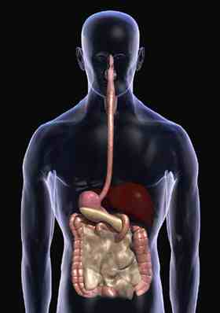

Breathing, eating, walking, etc, are very natural human functions.  But most people do not think about how these basic actions take place.  For example, when you eat a fruit, you do not contemplate on how it will be made useful to your body.  The only thing on your mind is eating a satisfying meal; at the same time, your body is involved in extremely detailed processes unimaginable to you in order to make this meal a health-giving thing.

The digestive system where these detailed processes take place starts to function as soon as a piece of food is taken into the mouth.  Being involved in the system right at the outset, the saliva wets the food and helps it to be ground by the teeth and to slide down the esophagus.

The esophagus transports the food to the stomach where a perfect balance is at work.  Here, the hydrochloric acid present in the stomach digests the food.  This acid is so strong that it has the capacity to dissolve not only the food but also the stomach walls.  Of course, such a flaw is not permitted in this perfect system.  A secretion called mucus, which is secreted during digestion, covers all the walls of the stomach and provides a perfect protection against the destructive effect of the hydrochloric acid.  Thus the stomach is prevented from consuming itself.

The point that deserves attention here is that evolution can by no means explain the system briefly summarized above.  Evolution maintains that today’s complex organisms have evolved from primitive cellular forms by the gradual accumulation of small structural changes.  However, as stated clearly, the system in the stomach could in no way have been formed step by step.  The absence of even one factor would bring about the death of the organism.

When food is received into the stomach, the ability of the gastric juices to break down food is effectuated as a result of a series of chemical changes.  Now, imagine a living being in the so-called evolutionary process in whose body such a planned chemical transformation is not complete.  This living being, unable to develop this ability autonomously, would not be able to digest the food it ate and would starve to death with an undigested mass of food in its stomach.

In addition, during the secretion of this dissolving acid, the stomach walls simultaneously have to produce the secretion called mucus.  Otherwise, the acid in the stomach would destroy the stomach.  Therefore, in order for life to continue, the stomach must secrete both fluids (acid and mucus) at the same time.  This shows it was not a step-by-step coincidental evolution that must, in effect, have been at work, but rather a conscious creation with all its systems intact.

What all this shows is that the human body resembles a huge factory made up of many small machines that work together in perfect harmony.  Just as all factories have a designer, an engineer and a planner, the human body has an “Exalted Creator.”